REPORT

MULTI SOURCE APPROACH FOR CROWD DENSITY ESTIMATION

* CURRENT PROGESS / WORK COMPLETED

Parts of LBP and HOG algorithm have been implemented .

HOG (Steps followed)

1.Convert RGB image to grayscale

2. Find Gradients in X and Y direction(Ix,Iy).

3.Find the magnitude and angle.

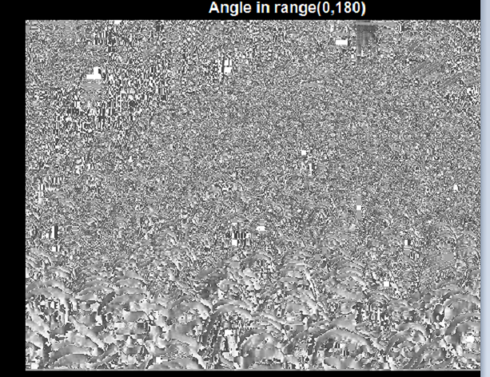

Also, the magnitude of the image is computed .

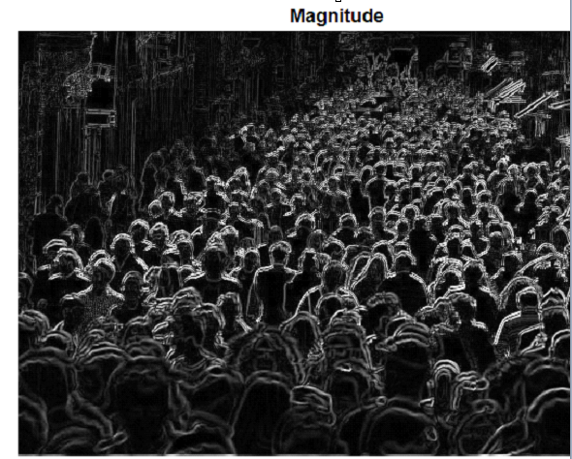

4.Remove redundant pixels in an image.

5. Initialized the feature vector

6. Iterate on block size & cell size

7.Use Binning Process (Bi-Linear Interpolation) to separate the histograms. Concatenate the Four histograms to form one block feature

8. Normalize the values in the block using L1-Norm

Removing Infinity values

9.Normalization of the feature vector using L2-Norm

\*LBP Patch Part :

⦁ Each pixel is compared to its neighbours and the neighbours can be 8, 12 etc. The value of neighbour pixel is greater than centre pixel, fill 1 otherwise fill 0.

2. 8 bit binary number is obtained and converted it to decimal

3.co-occurrence matrix calculated over LBP image to extract texture features such as energy, contrast, homogeneity and entropy:

4. Moreover, we also compute gradient map and Gray level based co-occurrence

matrix.

5. Feature vector both the LBPCM Gray and LBPCM gradient feature vectors are

concatenated. The final feature vector used for training support vector

Regression.

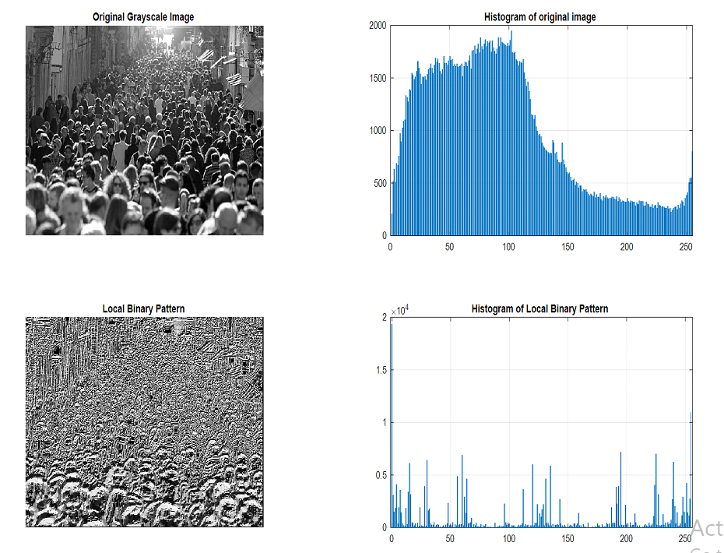

Parameters Calculated :

Contrast: [9.7514 14.3169 12.5771 16.8262]

Correlation: [0.3781 0.0858 0.1975 -0.0745]

Energy: [0.0494 0.0348 0.0385 0.0347]

Homogeneity: [0.5230 0.4277 0.4970 0.3983]

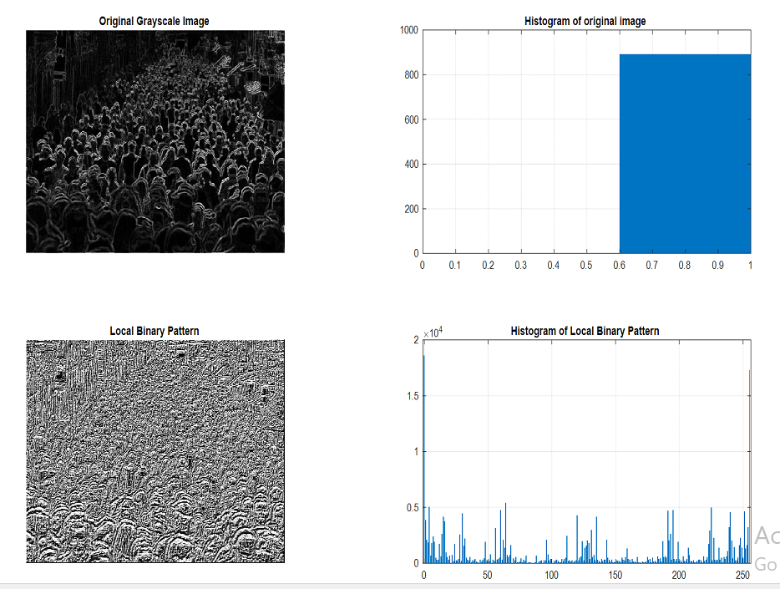

2. MILESTONES LEFT :

1. Calculating the count using Fourier Analysis , and calculating the parameters –entropy ,energy , etc and feed into a SVM .
2. Combining all the 3 parts of the codes , compare the error rate and feed them into SVM.
3. Trying the same system with Voila Jones Algorithm.

3. Code opened in MATLAB & uploaded to Github.